**Installing the Camera**

**The First Step: Connecting the Cable**

Details: (Supports 40 x 40 to 2592 x 1944

Which is 26kB to 2.5MB)

To connect the Raspberry Pi camera to the Raspberry Pi, simply locate the camera plug and unlatch it. It will look like this:

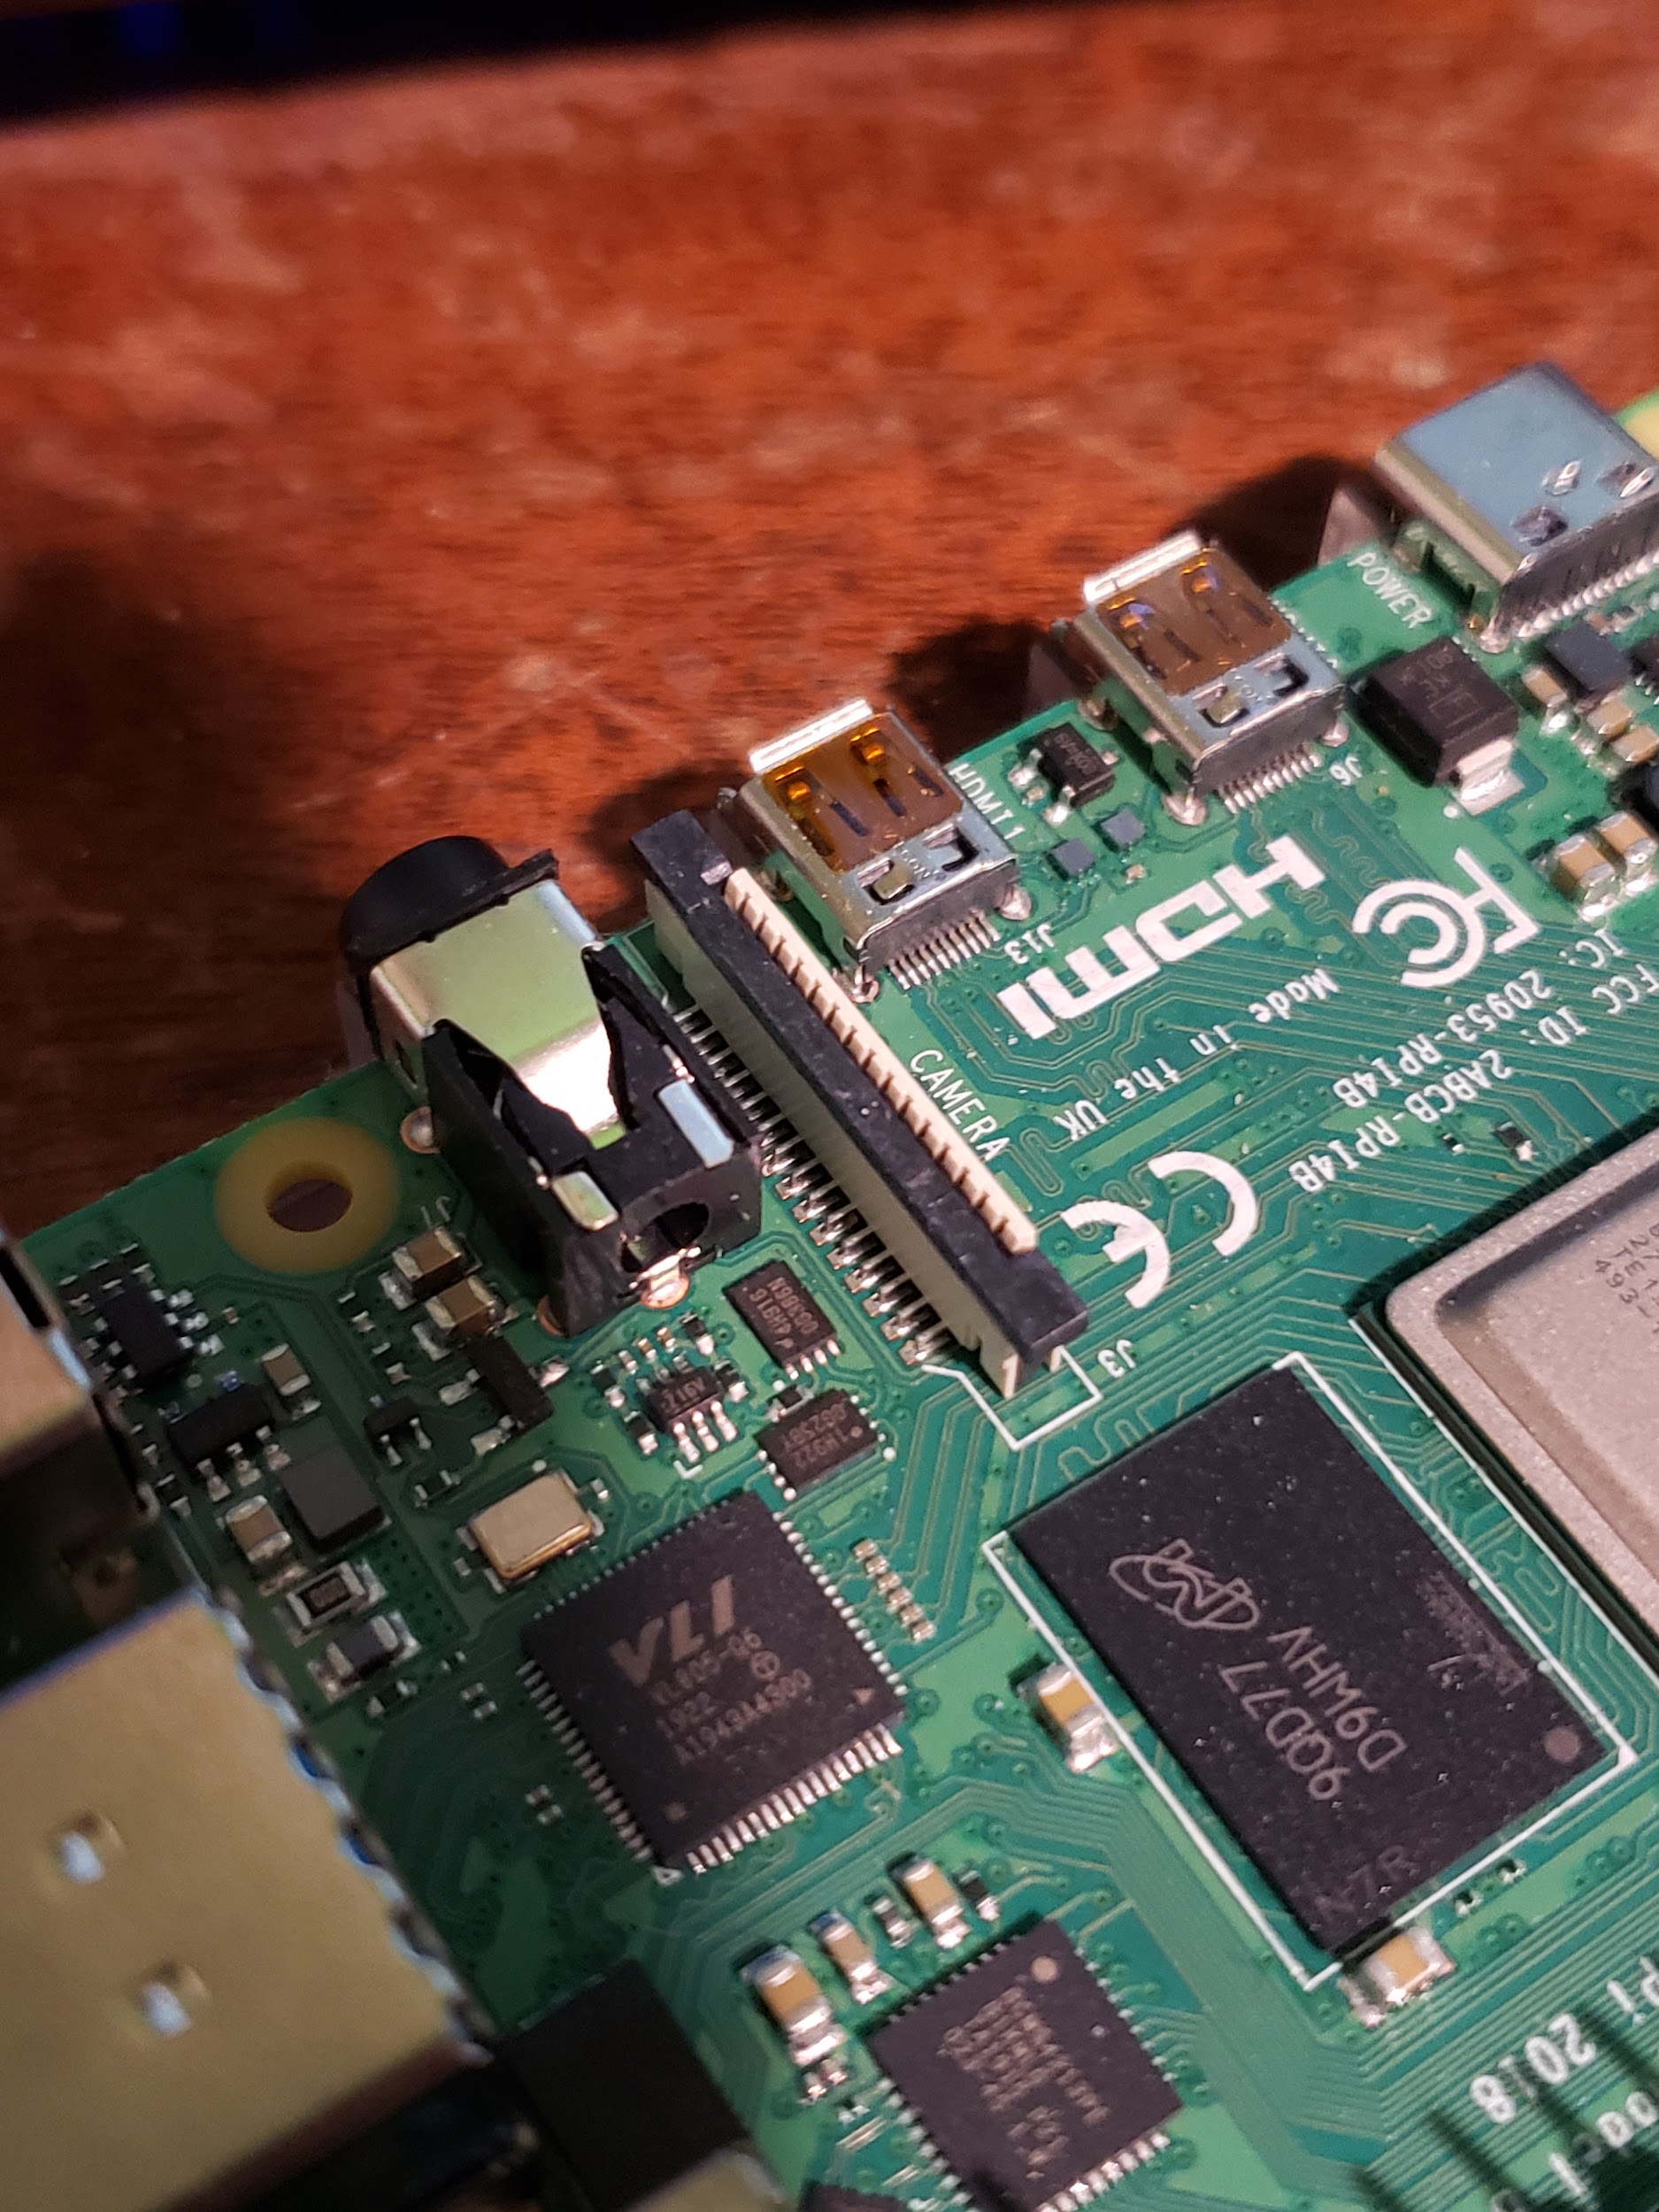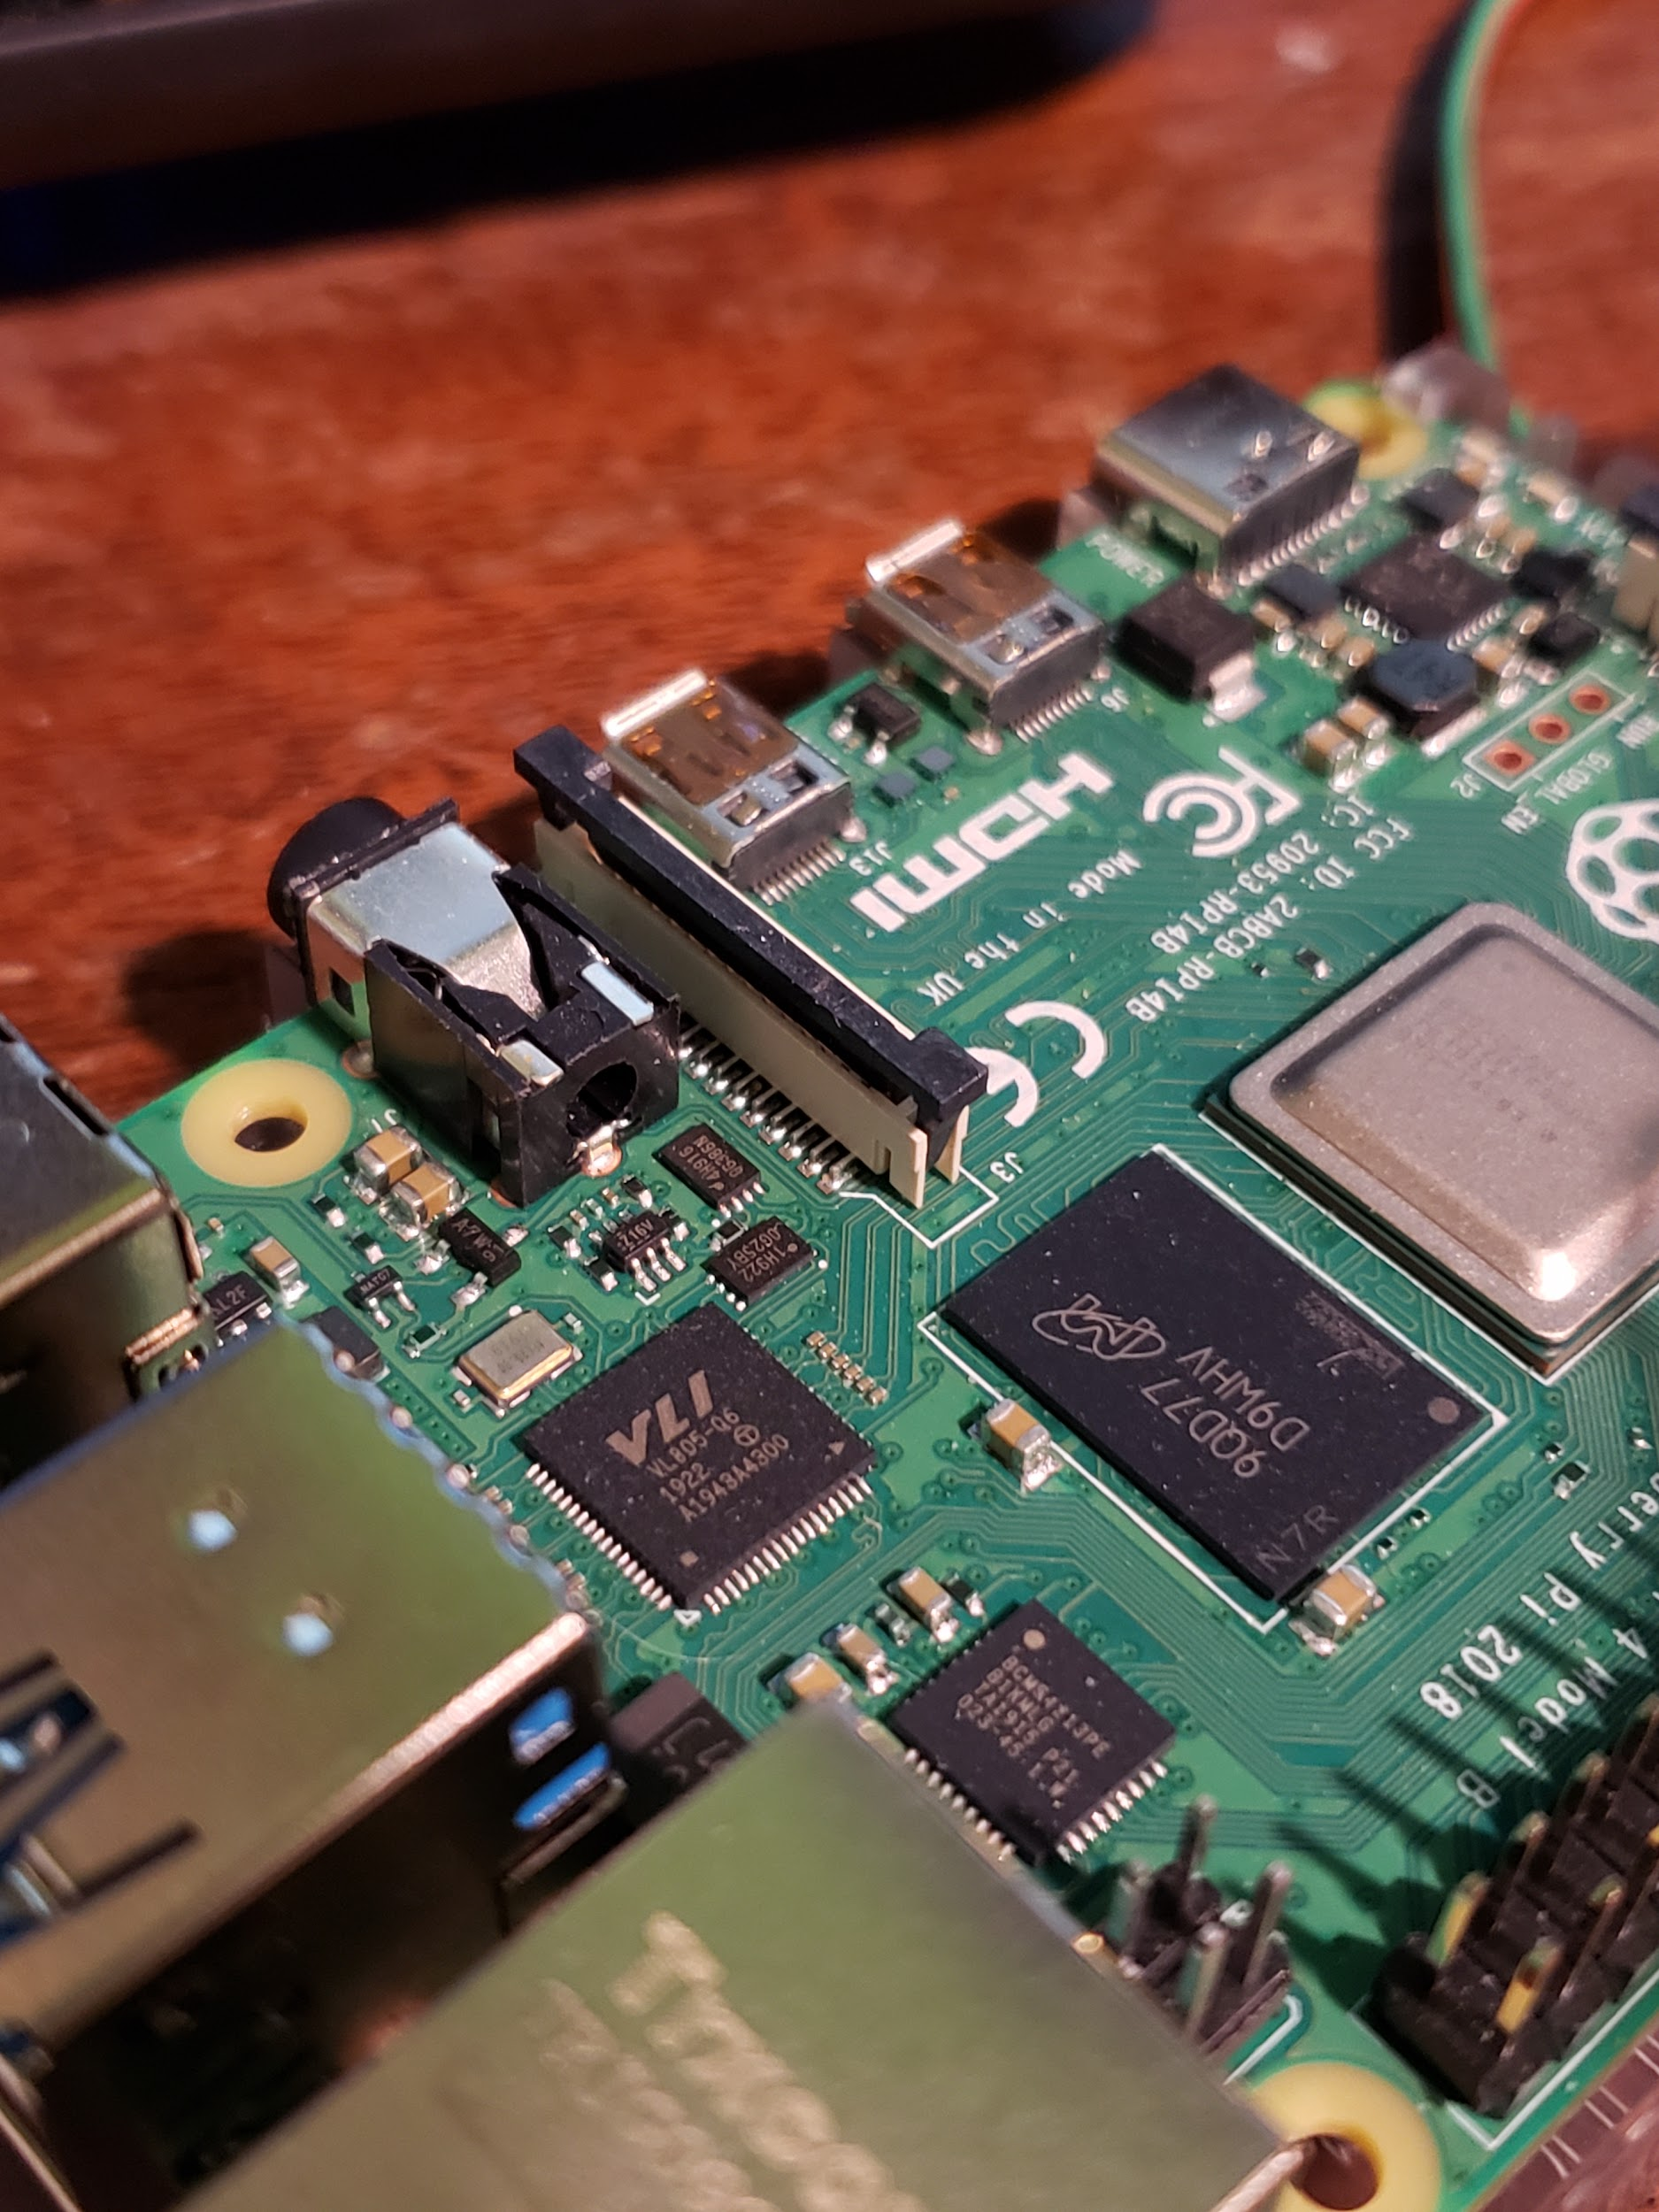

(latched vs. unlatched)

Then slide the camera’s cable into place with the blue side facing the USB ports like so:

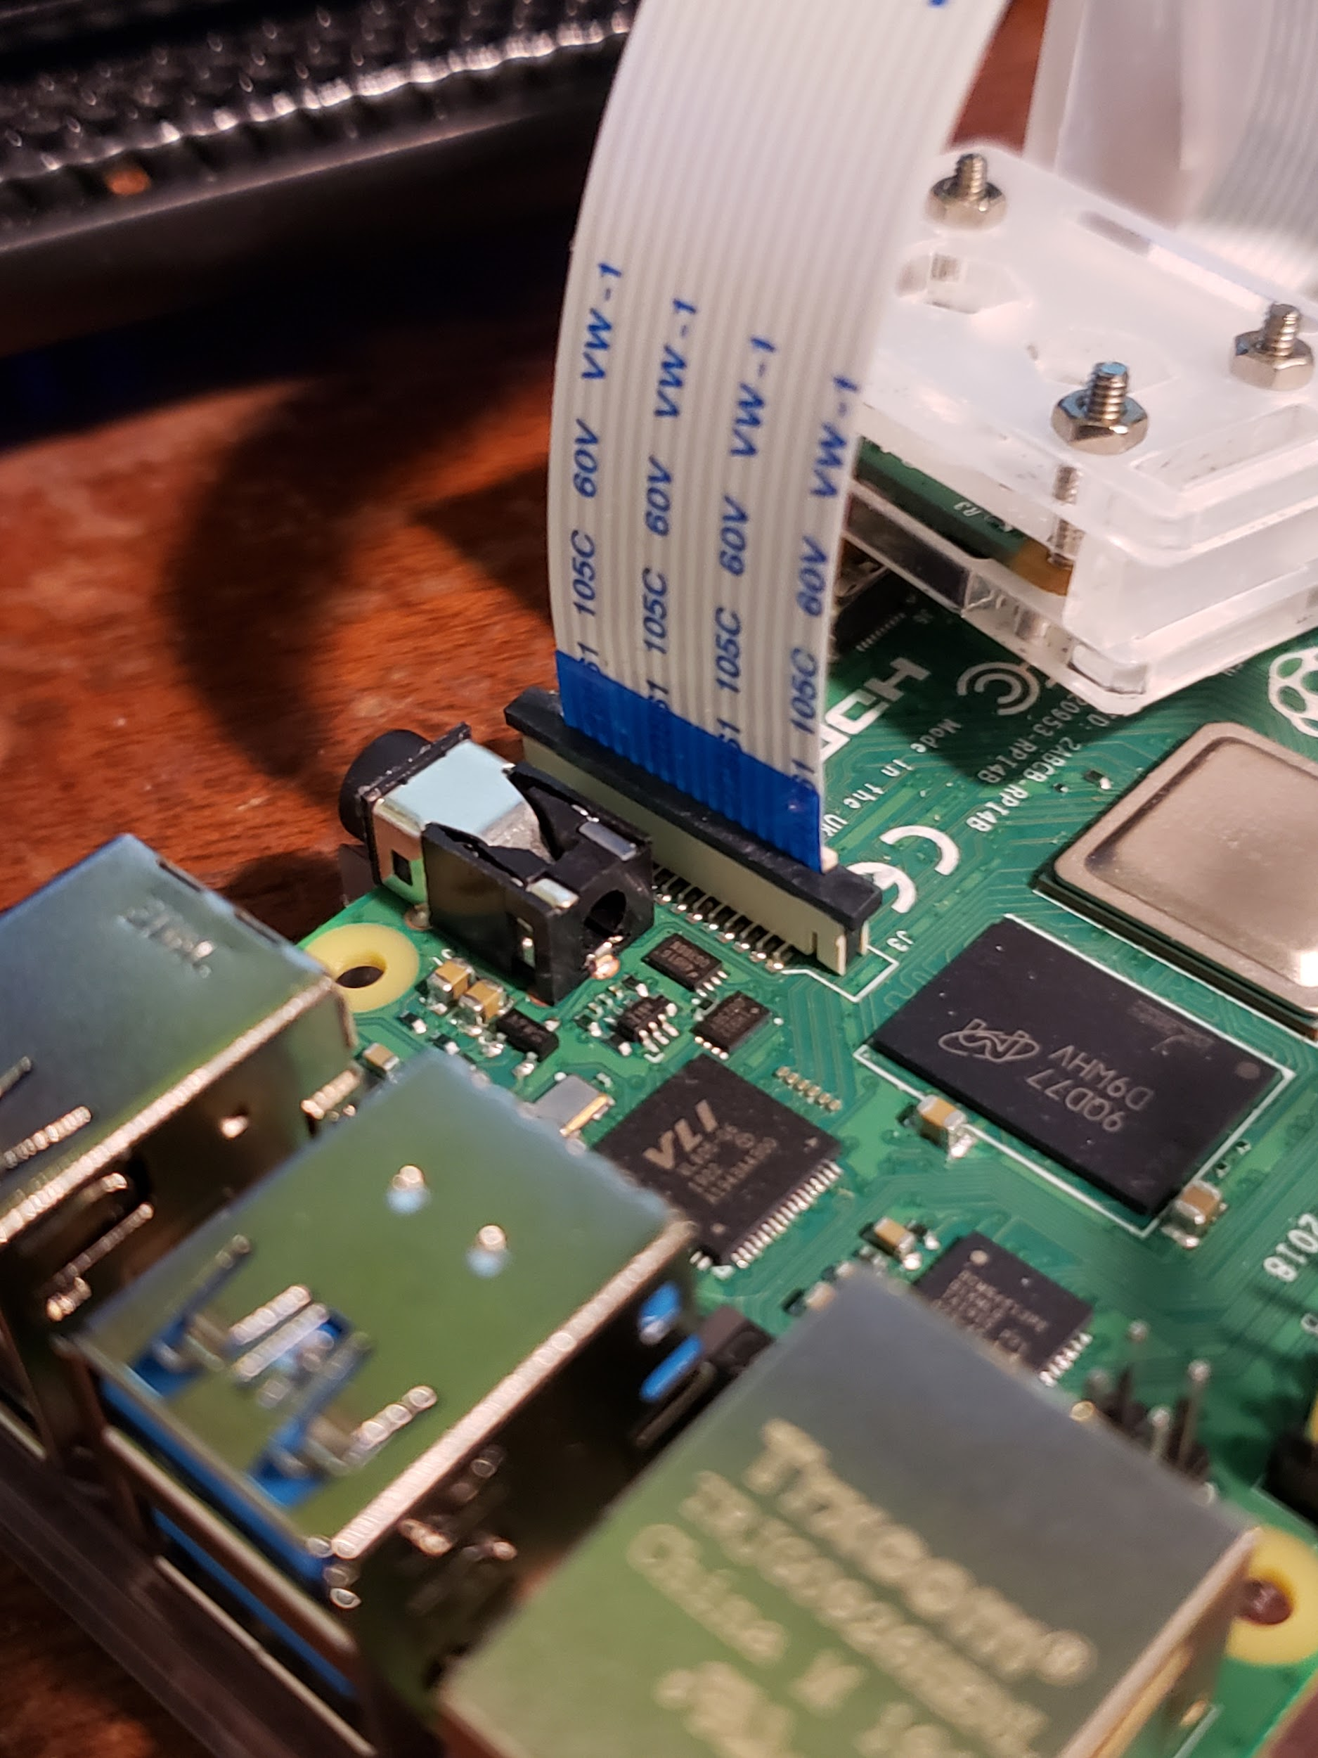

Once in place push the black latch down into place to clamp it all down.

**The Second Step: Programming and Setting up the Software**

The first thing you will have to do is run the command **sudo raspi-config**

This will bring you to a screen of various options, simply scroll down to option 5 or interfacing options. Should look like this:

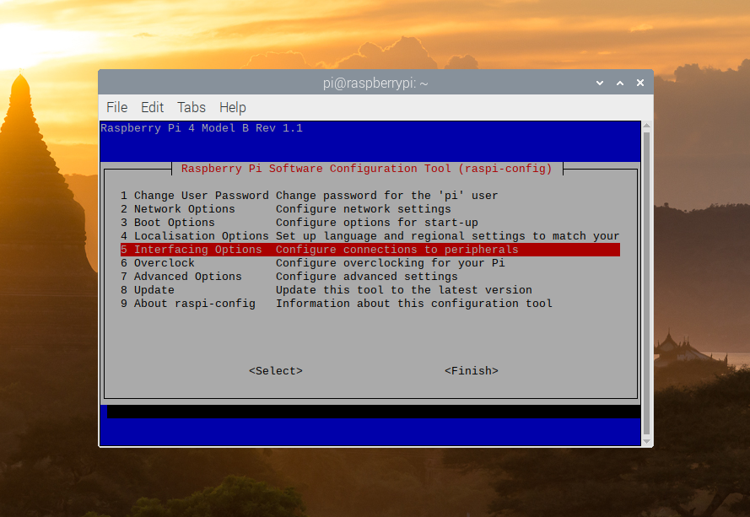

Press enter to continue on, and it should be on option 1 which is the camera option. You will want to press enter again and make sure the camera interface is enabled.

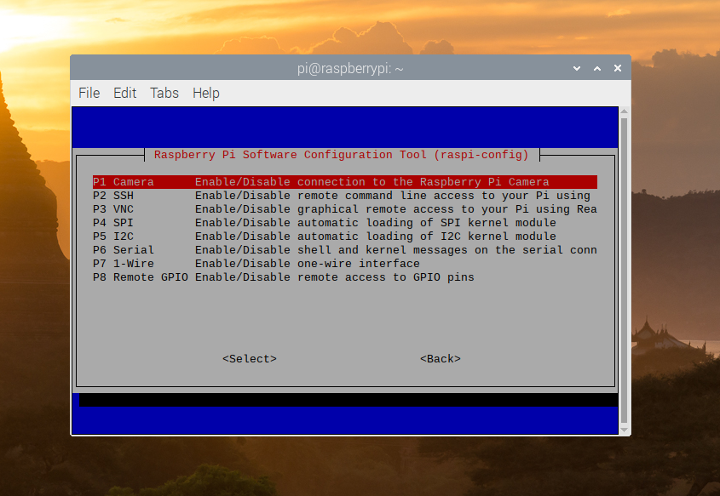

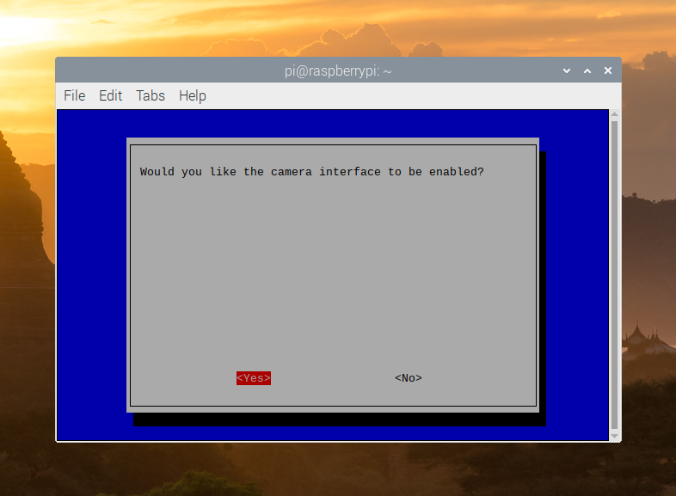

(press enter once more on this screen)

Once this is done, you are ready to begin programming with the camera. Some simple code to get you started would be:

*from picamera import PiCamera*

*from datetime import datetime*

*camera = PiCamera()*

*timestamp = datetime.now().isoformat()*

*camera.capture('/home/pi/Documents/Code/Pictures/%s.jpg' % timestamp)*

This code simply takes a picture and then names it the timestamp, you will likely need to change the file path to fit your own pi.